SEASONAL AGRICULTURE
PERFORMANCE ANALYSIS
Project Report

Student Name | MRUNALI SAYAJI MINDE
AICTE ID | STU6a633feae3b6b1784889322
Domain | Agriculture
Project Theme | Seasonal Performance Analysis
Analysis Environment | Python / Jupyter Notebook
Internship ID | IBMUEDA4647

Table of Contents
1. Introduction to the Dataset
2. Problem Statement
3. Importance of the Problem
4. Objectives
5. End Users
6. Technology and Tools Used
7. Dataset Structure and Data Preparation
8. Analytical Methodology
9. Graphical and Statistical Analysis
10. Key Findings
11. Conclusion
12. Future Scope
13. Project Repository
14. Appendix: Notebook Workflow

1. Introduction to the Dataset
The dataset represents agricultural activities carried out across different seasons, geographical areas and farming conditions. It contains information related to farming practices, environmental conditions, crop production, resource usage and economic performance.
The project uses the dataset to explore how agricultural performance changes across seasons and to identify meaningful patterns and differences through data analysis.

2. Problem Statement
Agricultural activities are influenced by seasonal variations in environmental conditions, farming practices, resource availability and market conditions. As a result, agricultural performance may differ from one season to another.
Raw agricultural data does not clearly explain how agricultural performance changes across seasons or what patterns can be observed in different seasonal conditions. The project therefore analyzes the agricultural dataset to investigate seasonal differences in performance by identifying meaningful patterns, trends, relationships and variations.

3. Importance of the Problem
- Understand variations in agricultural performance.
- Identify important seasonal trends.
- Compare performance across different periods.
- Understand changing environmental conditions.
- Examine differences in resource usage.
- Identify areas requiring further investigation.
- Support evidence-based agricultural planning.
The project is intentionally focused on a real-world seasonal data analytics problem rather than a generic analysis of the entire dataset.

4. Objectives
- Explore and understand the agricultural dataset.
- Clean and prepare the data for analysis.
- Examine how agricultural performance varies across seasons.
- Identify important seasonal patterns and trends.
- Investigate relationships between seasonal conditions and agricultural outcomes.
- Compare relevant groups within different seasons.
- Identify significant differences or unusual patterns.
- Apply appropriate statistical and visualization techniques.
- Interpret findings based on evidence from the dataset.
- Develop meaningful conclusions and data-driven recommendations.

5. End Users
End user | Project use
Farmers | Understand seasonal yield, profitability and resource-efficiency patterns.
Agricultural Planners | Support seasonal crop and resource planning.
Agricultural Researchers | Study relationships between environmental conditions and agricultural outcomes.
Government & Agriculture Departments | Support evidence-based agricultural planning.
Agribusinesses | Understand production, costs, market performance and seasonal opportunities.
Data Analysts | Identify seasonal trends, correlations and unusual patterns.

6. Technology and Tools Used
Technology | Role in project
Python | Core programming language.
Jupyter Notebook | Development and data-analysis environment.
Pandas | Data cleaning, preprocessing, grouping and analysis.
NumPy | Numerical computations and selection of numeric columns.
Matplotlib | Data visualization.
Seaborn | Statistical charts and visualizations.
CSV | Dataset/input data format.

7. Dataset Structure and Data Preparation
The submitted notebook loads the seasonal agriculture CSV dataset with Pandas and performs an initial data-understanding stage before visualization.
Item | Notebook result
Rows | 4,000
Columns | 28
Data types | 17 float, 5 integer, 6 object columns
Duplicate records before removal | 0
Missing values | Present in Rainfall_mm, Soil_Moisture_pct and Yield_Tonnes_Ha

The notebook explicitly performs the following preparation and inspection steps:
- Loads the CSV dataset using Pandas.
- Displays the first and last five records.
- Generates a statistical summary using DataFrame.describe().
- Checks data types and non-null values using DataFrame.info().
- Checks the dataset shape and column names.
- Checks missing-value counts and missing-value percentages.
- Checks duplicate records and applies drop_duplicates().
- Selects numeric columns for correlation analysis.

Main Dataset Variables
The notebook contains variables covering farm identification and location, crop and season, farm area, rainfall, temperature, humidity, sunlight, soil characteristics, nutrients, irrigation method, fertilizer and pesticide usage, seed quality, yield, production, market price, cost, revenue, profit, water use, water efficiency and disease/pest risk.

8. Analytical Methodology
- Load the agricultural CSV dataset into a Pandas DataFrame.
- Inspect records, dimensions, column names and statistical summaries.
- Check missing values and duplicate records.
- Compare crop distribution and rainfall distribution using descriptive visualizations.
- Compare average yield across Kharif, Rabi and Zaid seasons.
- Study temperature versus yield using a season-wise scatter plot.
- Compare yield distributions using a seasonal box plot.
- Analyze numerical relationships using a correlation heatmap and pairplot.
- Analyze average profit by crop and season.
- Compare pesticide usage for Sugarcane, Chilli and Cotton across seasons.
- Calculate the correlation between pesticide usage and profit for each crop.
- Interpret the visual and statistical findings and document conclusions and future scope.

9. Graphical and Statistical Analysis
The following figures are the charts used in the project presentation and correspond to the analysis performed in the Jupyter Notebook. The explanations below follow the documented project interpretation.

9.1 Distribution of Crops
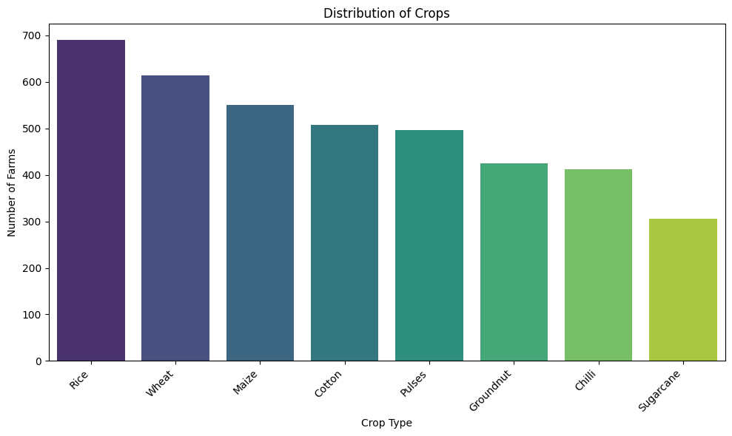
Figure: 9.1 Distribution of Crops
Analysis: Rice has the highest representation at approximately 690 farms, followed by Wheat at around 615 and Maize at approximately 550. Cotton and Pulses are around 510 and 500 farms, while Groundnut and Chilli are around 425 and 415. Sugarcane has the lowest representation at approximately 305 farms. The chart therefore shows that Rice, Wheat and Maize are the dominant crop categories in the dataset.

9.2 Distribution of Rainfall
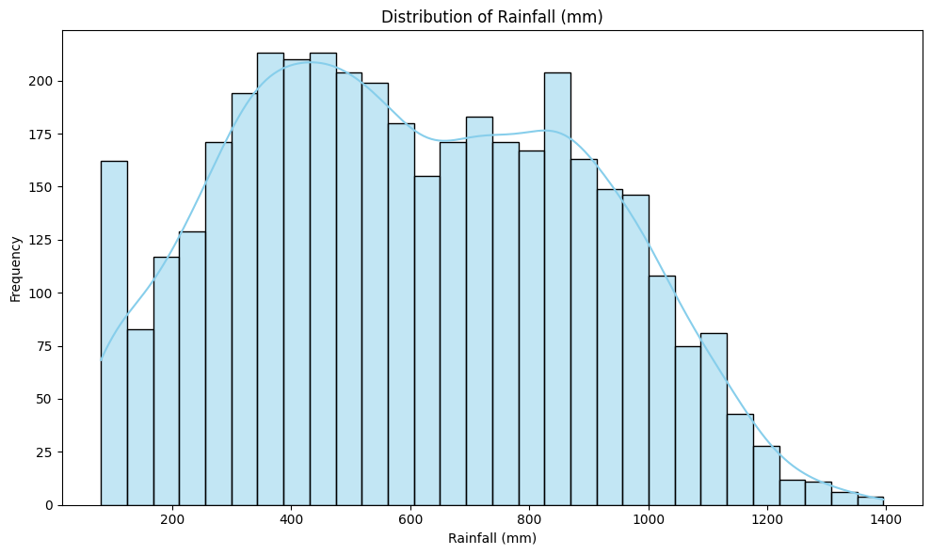
Figure: 9.2 Distribution of Rainfall
Analysis: Rainfall observations range approximately from 80 mm to 1,400 mm. The highest frequency is concentrated around 350–550 mm, with another noticeable concentration around 700–900 mm. Values above 1,000 mm become less frequent toward 1,400 mm. The documented interpretation describes the distribution as not perfectly normal and as having a longer upper tail.

9.3 Average Yield Across Seasons
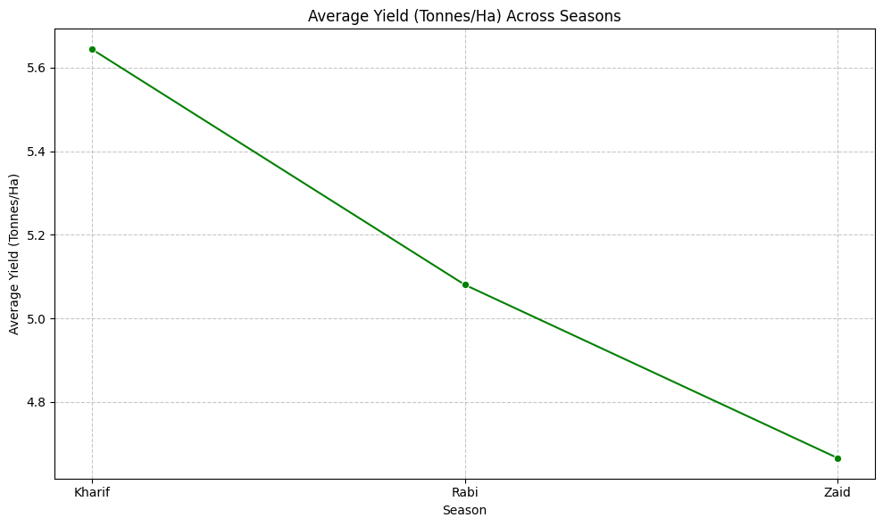
Figure: 9.3 Average Yield Across Seasons
Analysis: Average yield is approximately 5.65 tonnes/ha for Kharif, 5.08 tonnes/ha for Rabi and 4.67 tonnes/ha for Zaid. The project presentation describes a gradual decline from Kharif to Zaid and notes that seasonal conditions may influence crop productivity.

9.4 Average Temperature vs Yield
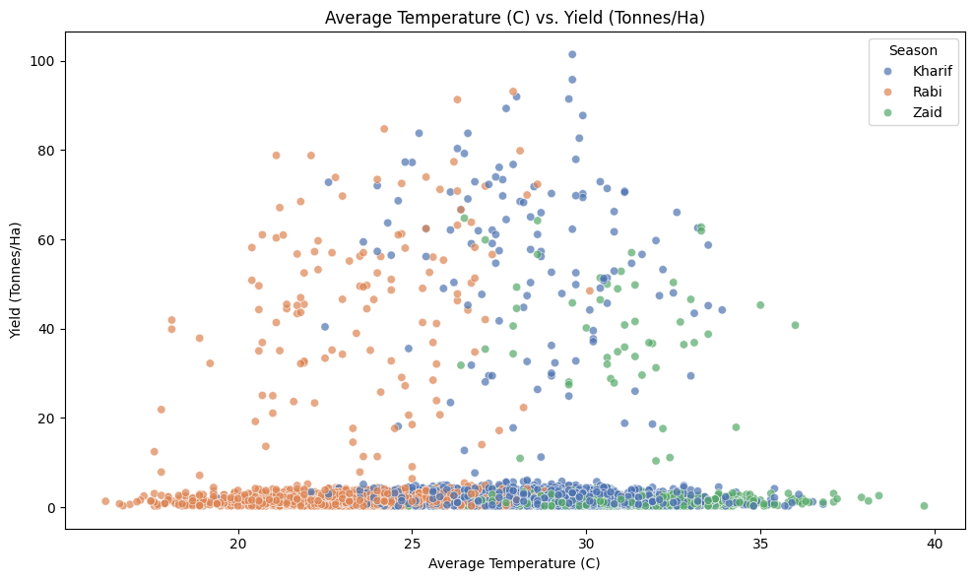
Figure: 9.4 Average Temperature vs Yield
Analysis: The scatter plot compares average temperature with crop yield for Kharif, Rabi and Zaid. The documented interpretation notes that many observations are concentrated at lower yield levels, while some farms show substantially higher yields. Kharif contains several high-yield observations above 100 tonnes/ha, while Rabi and Zaid generally show lower maximum yields. The project concludes that temperature alone does not show a clear direct relationship with yield.

9.5 Yield Distribution by Season
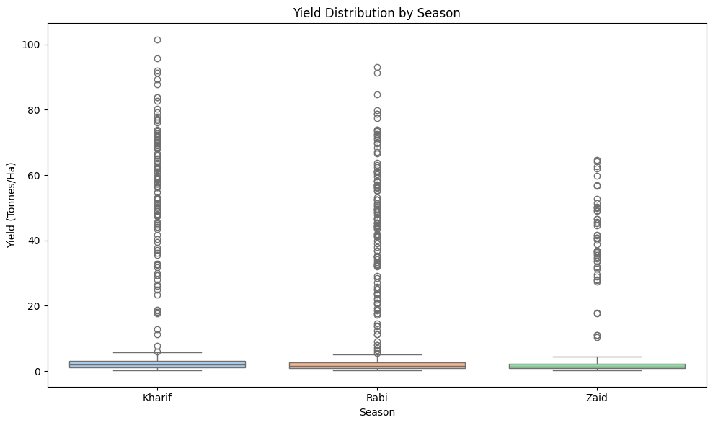
Figure: 9.5 Yield Distribution by Season
Analysis: The box plot shows that typical yield levels are relatively similar across the three seasons, while Kharif shows the highest variability and maximum yield values. Rabi also contains high-yield observations, whereas Zaid has a comparatively lower yield range. The project presentation notes a large number of outliers, indicating substantial farm-level variation.

9.6 Correlation Heatmap of Numeric Variables
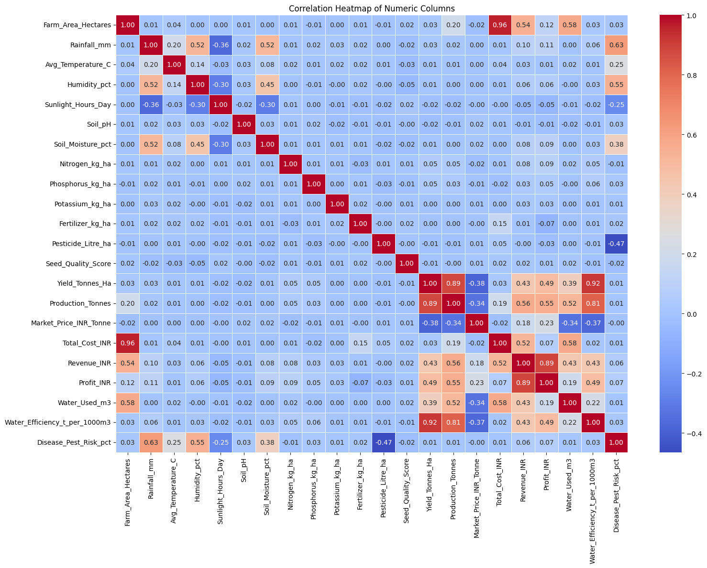
Figure: 9.6 Correlation Heatmap of Numeric Variables
Analysis: The heatmap summarizes pairwise correlations among the numerical variables used in the dataset. It is used as a broad screening tool for relationships among environmental, input, production and economic variables before interpreting more focused relationships.

9.7 Pairplot of Key Numerical Features
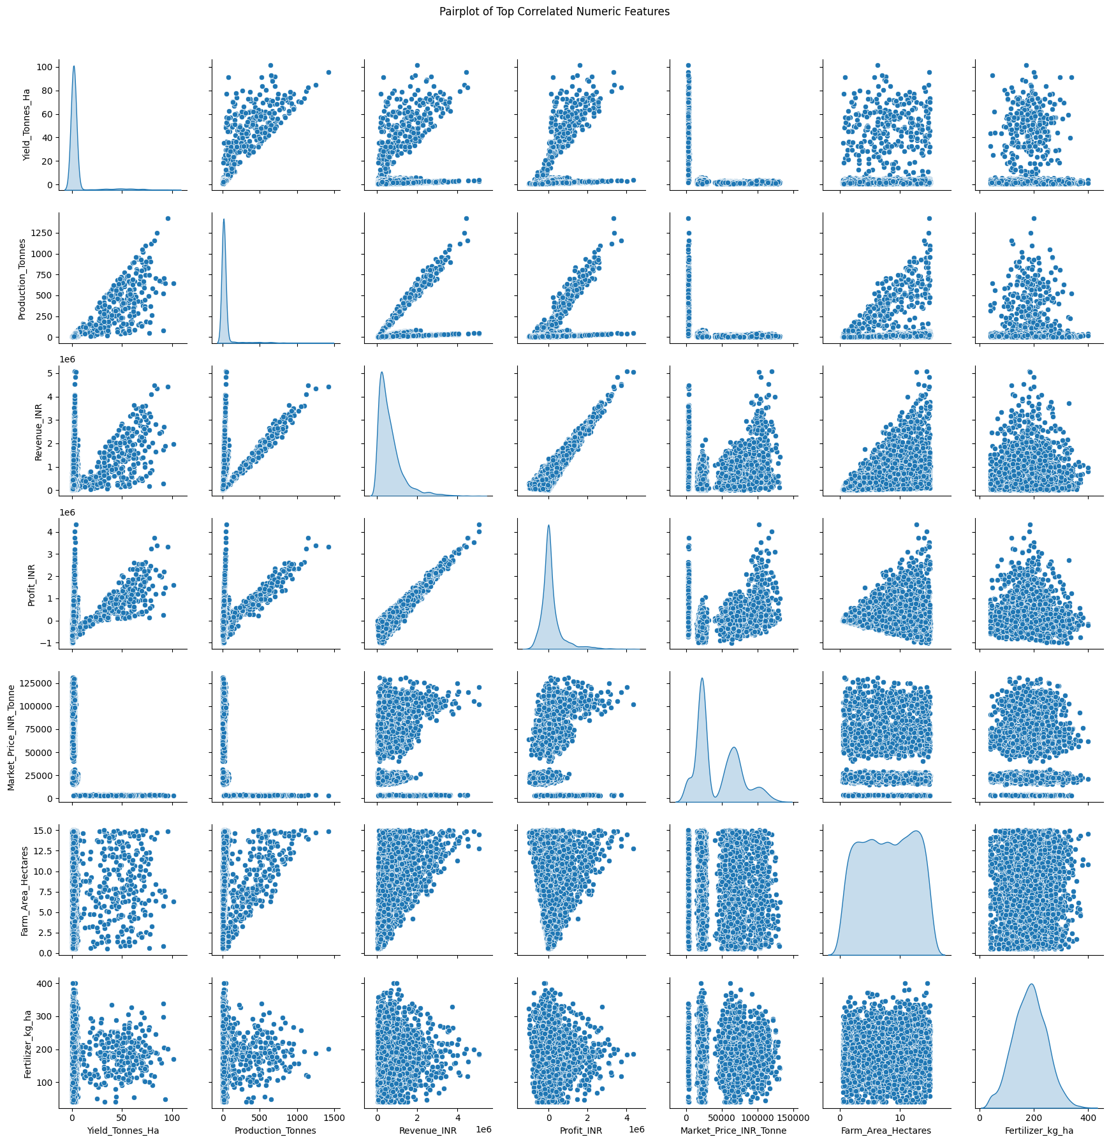
Figure: 9.7 Pairplot of Key Numerical Features
Analysis: The project presentation describes the pairplot as showing strong positive relationships among Yield, Production, Revenue and Profit. Farm area and fertilizer usage also show noticeable relationships with these variables. The plots contain outliers and skewed distributions, including observations with unusually high production, revenue or yield.

9.8 Average Profit per Crop Across Seasons
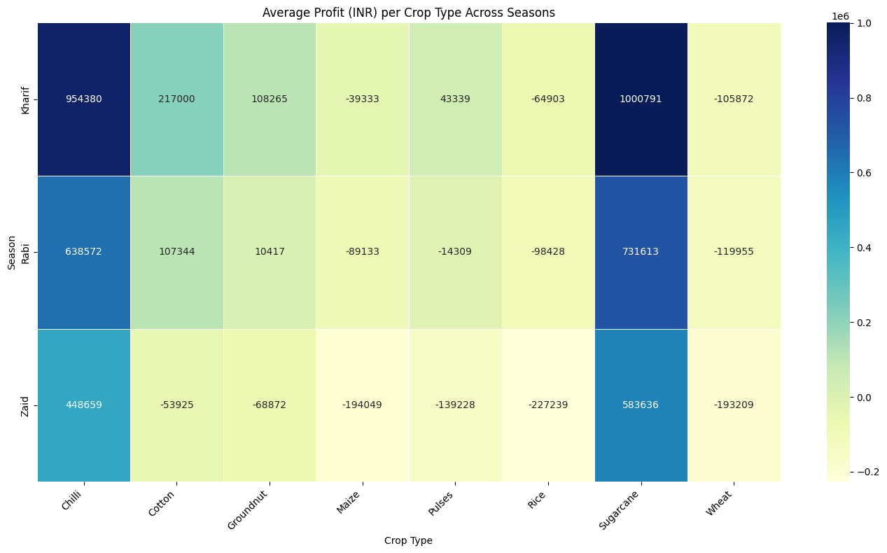
Figure: 9.8 Average Profit per Crop Across Seasons
Analysis: The seasonal crop-profit heatmap shows substantial differences in profitability by crop and season. The documented findings identify Sugarcane and Chilli as especially profitable, particularly in Kharif. Kharif shows the highest overall profitability, while Zaid is described as the lowest. Cotton and Groundnut are profitable mainly during Kharif but show losses in Zaid, while Maize, Rice and Wheat record negative profits across all three seasons.

9.9 Average Profit for the Top 3 Crops Across Seasons
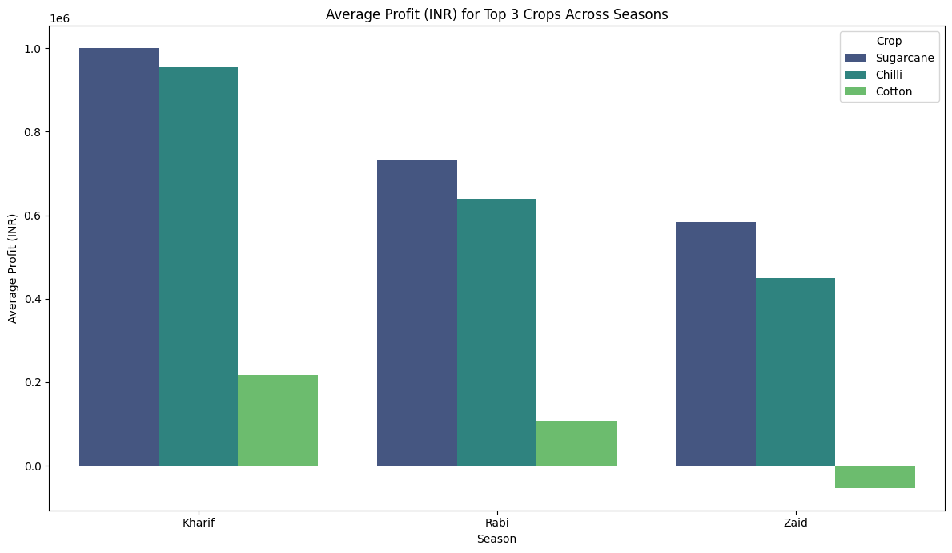
Figure: 9.9 Average Profit for the Top 3 Crops Across Seasons
Analysis: Sugarcane is described as the most profitable crop across all three seasons, reaching approximately ₹10 lakh in Kharif. Chilli ranks second, with around ₹9.5 lakh in Kharif and ₹6.4 lakh in Rabi. Cotton performs moderately in Kharif and Rabi but shows a loss in Zaid. Kharif is the most profitable season for these three crops in the documented analysis.

9.10 Pesticide Usage for Selected Crops
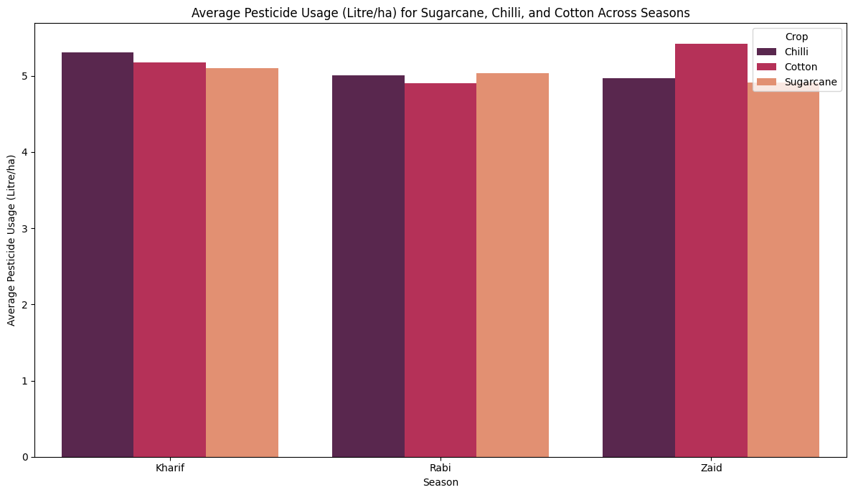
Figure: 9.10 Pesticide Usage for Selected Crops
Analysis: For Sugarcane, Chilli and Cotton, pesticide usage remains fairly similar across seasons but shows some differences. Chilli has the highest usage in Kharif at approximately 5.3 L/ha, while Cotton reaches approximately 5.4 L/ha in Zaid. Sugarcane remains relatively consistent at around 5.0–5.1 L/ha. Rabi shows slightly lower usage for Chilli and Cotton than Kharif and Zaid.

9.11 Correlation Between Pesticide Usage and Profit
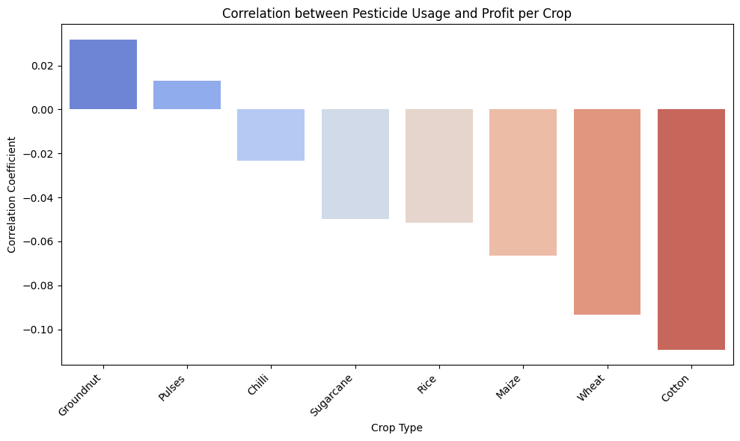
Figure: 9.11 Correlation Between Pesticide Usage and Profit
Analysis: Groundnut and Pulses show slightly positive correlations between pesticide usage and profit, while Chilli, Sugarcane, Rice, Maize, Wheat and Cotton show negative correlations. Cotton has the strongest negative correlation in the documented analysis. However, the project notes that the correlation values are close to zero overall, suggesting little direct relationship between pesticide usage and profit. Other factors such as yield, production, market price, rainfall and input costs may have greater influence on profitability.

10. Key Findings
- The dataset contains 4,000 farm observations and 28 variables covering environmental, farming, production, resource-use and economic measures.
- Rice is the most represented crop in the dataset, while Sugarcane has the lowest representation.
- Most rainfall observations fall in moderate ranges, with fewer observations at very high rainfall levels.
- Average yield differs across seasons, with the documented averages being approximately 5.65 tonnes/ha for Kharif, 5.08 for Rabi and 4.67 for Zaid.
- Temperature alone does not show a clear direct relationship with yield in the documented scatter-plot interpretation.
- Yield varies substantially between farms, with notable high-value observations and outliers.
- Yield, Production, Revenue and Profit show strong positive relationships in the pair plot described in the project presentation.
- Profitability varies considerably by crop and season. Sugarcane and Chilli show particularly strong profitability in Kharif.
- Cotton and Groundnut are described as profitable mainly in Kharif but loss-making in Zaid.
- Maize, Rice and Wheat are described as having negative profits across all three seasons in the presented analysis.
- Pesticide usage varies only moderately among the selected crops and seasons.
- The documented pesticide-profit correlations are mostly weak, indicating that pesticide usage by itself is not a strong direct explanation of profit in this dataset.

11. Conclusion
The Seasonal Agriculture Performance Analysis demonstrates how descriptive statistics, grouping, correlation analysis and visualization can be used to understand agricultural performance across seasons.
The analysis identifies clear differences in seasonal yield and profitability and highlights substantial variation among crops. The results also show that agricultural outcomes cannot be interpreted from a single environmental factor such as temperature or pesticide usage alone. Production, yield, market and input-related variables are closely connected to the economic outcomes represented in the dataset.
Overall, the project provides an evidence-based analytical view of seasonal agricultural performance and creates a foundation for further predictive and decision-support applications.

12. Future Scope
Future enhancement | Description
Crop Recommendation System | Recommend suitable crops based on season, soil, rainfall, temperature and other conditions.
Yield Prediction | Use machine-learning models to predict crop yield for upcoming seasons.
Weather Integration | Integrate real-time weather data to improve seasonal agricultural analysis.
Real-Time Monitoring | Develop a dashboard for continuous monitoring of agricultural performance and environmental conditions.
Regional Analysis | Expand analysis to more states, districts and geographical regions.
Resource Optimization | Use predictive analytics to recommend efficient use of water, fertilizers and pesticides.
Profit Prediction | Predict expected revenue, cost and profit from crop and seasonal conditions.
Mobile/Web Application | Convert the analysis into an accessible application for farmers and agricultural planners.
AI-Based Decision Support | Provide data-driven recommendations for seasonal crop planning.
Advanced Analytics | Apply machine-learning and time-series techniques to identify deeper seasonal patterns and trends.

13. Project Repository
https://github.com/Mruunali/-Seasonal-Agriculture-Performance-Analysis

14. Appendix: Notebook Workflow
- Import NumPy, Pandas, Matplotlib and Seaborn.
- Load the seasonal agriculture CSV file.
- Inspect the first and last five records.
- Generate descriptive statistics.
- Inspect data types and non-null counts.
- Check rows, columns and column names.
- Calculate average profit by crop and identify the top five profitable crops.
- Check missing values and missing-value percentages.
- Check and remove duplicate records.
- Create crop distribution and rainfall distribution charts.
- Calculate and visualize average yield across Kharif, Rabi and Zaid.
- Visualize temperature versus yield by season.
- Compare yield distributions using a box plot.
- Calculate and visualize correlations among numeric columns.
- Analyze average profit by crop and season.
- Compare the top three profitable crops across seasons.
- Analyze pesticide usage for Sugarcane, Chilli and Cotton.
- Calculate crop-wise correlation between pesticide usage and profit.

